**Dutch Student 2K Team Racing Silver Fleet–**

**13-14 May, 2023**

**NOTICE OF RACE**

Abbreviations:

OA – organising authority RRS – racing rules of sailing

NoR – Notice of Race SSI – Standard Sailing Instructions

1. **ORGANISING AUTHORITY**

The Organising Authority (OA) is the Rotterdamse Studenten Zeil Vereeniging (RSZV) under the auspices of the Royal Netherlands Watersport Association.

Contact: teamzeilen@rszv.nl Website: http://rszv.nl/nsk

1. **VENUE**

The venue will be the Rotterdamsche Zeilvereeniging (RZV). Kralingse Plaslaan 113, Rotterdam, the Netherlands.

1. **PROVISIONAL PROGRAMME**
   * 1. The Race Office will be open on May 14 and May 15 from 0830h until 2000h.
     2. Registration will be on May 14 from 0830 until 0930 unless extended by the OA.
     3. The first briefing for the team captains and skippers will be on May 14 at 0930.
     4. The first meeting with umpires will be immediately on completion of the first briefing.
     5. Racing days are May 13 and May 14.
     6. The time of the warning signal of the first race will be 1415 on May 13 and 1000 on May 14.
     7. A debrief will be organised as soon as possible after the last race of the day.
     8. Daily interviews will be held after racing.
     9. The latest time for a warning signal on the last day of racing will be 1400.
     10. Prize giving will be on Sunday May 15 at approximately 1630.
   1. Unless excused by the OA, attendance at the following is mandatory:
      1. Daily briefing for the team captains and skippers.
      2. Debriefing
      3. Daily interviews for team captains
      4. Prize giving for all teams.
2. **TEAMS ELIGIBILITY.**
   1. Only teams accepted by the OA after registration will be eligible to enter this event. Teams shall fully consist of students. Competitors shall be able to show proof of registration to an educational institution, of the current academic year, at registration. One place is reserved for a team representing the host club. The remaining places will be allocated on a “first come first serve” basis.
3. **ENTRIES**
   1. Entering

The team shall be entered on completion of registration, the payment of all fees and deposits and signing of the “Sailing Agreement”. The entry fee and the damage deposit shall be received on the bank account as specified under 17 of this NoR before the Closing Date.

* 1. Entry Procedure
     1. Registration will close on 29-04-2023.
     2. If at 1800 on the Closing Date the minimum number of teams have entered the event will proceed.
     3. If at 1800 on the Closing Date there are insufficient entries the event will be cancelled, and the entry fee less any bank charges will be returned.
  2. Entry Fee
     1. A non-refundable entry fee of € 330,- per team or €55,- per individual participant shall be received on the bank account as specified under 17 of this NoR before the Closing Date.
  3. Withdrawal
     1. When a team accepts an invitation and later withdraws before the closing date, the entry fee (less any bank charges) will be returned.
     2. When a team accepts an invitation and later withdraws after the closing date, the entry fee will not be returned unless the team is able to find a replacement team that meets the requirements of this NOR.
     3. If the event has to be cancelled due to the applicable corona measures, the application will be postponed to a later date. No refunds will be issued.
  4. Damage deposit
     1. An initial damage deposit of € 500,- shall be paid prior to sailing, by issuing a debit for damage, unless extended by the OA. This deposit is the maximum payable by the skipper as a result of any one incident.
     2. If a deduction from the damage deposit is decided by the OA, it may require that the deposit be restored to its original amount before the team will be permitted to continue in the event.
     3. Any remaining deposit after the event will be refunded within 10 days after the event.
  5. Sailing Agreement

A “Sailing Agreement” (see addendum A) shall be signed by each team at registration before going afloat.

* 1. Insurance

All competitors are required to have adequate third party insurance.

1. **RULES**
   1. General
      1. The event will be governed by the ‘rules’ as defined in the RRS, including Appendix D, Team Racing Rules.
      2. The 2K Team Racing International Association Standard Sailing Instructions (SSI) will apply. These change some rules in the RRS; they are available on the 2K Team Racing website ([www.2Kteamracing.com](http://www.2kteamracing.com)) and at registration.
      3. The rules for Handling Boats (SSI Addendum A), will also apply to any practice sailing and sponsor races. Class Rules will not apply.
      4. The prescriptions of the national authority will apply and shall be posted on the official notice board.
      5. The right of appeal will be denied in accordance with RRS 70.5 (a).
      6. All races will be umpired.
2. **BOATS AND SAILS**
   1. The event will be sailed in Yngling boats.
   2. Six boats will be provided by the OA.
   3. Boats will be allocated by the Race Committee.
   4. This is a “White Sail” event, spinnakers will not be allowed.
3. **CREW** 
   1. A team shall comprise a total of 6 persons. All registered crew shall sail all scheduled races.
   2. There is no weight limit.
   3. When a registered crew member is unable to continue in the event the OA may authorise a substitute, a temporary substitute or other adjustment.
   4. Any team that is given permission to sail without the required number of crew may be allowed to sail, however they shall not be eligible to compete in any knockout stage and their results shall be discounted when final positions are calculated.
4. **EVENT FORMAT**
   1. The event will consist of the following stages:
      * Stage 1: Multiple round robins.
      * Stage 2: Finals, knock out (first to score 2 race wins).
   2. The OA may change the format, terminate or eliminate any round, when conditions or the remaining time scheduled do not permit the completion of the intended format.
5. **COURSE** 
   1. The course will be outerloop course with spreader mark, starboard roundings and finishing downwind. The course is specified in the Sailing Instructions.
   2. The intended course area is shown in addendum B.
6. **ADVERTISING**
   1. As boats and equipment will be supplied by the Organising Authority, World Sailing regulation 20.4 applies. Each boat may be required to display advertising as supplied by the OA.
   2. While racing, competitors may be required to wear bibs supplied by the OA.
   3. Boats shall not be permitted the right to protest for breaches of any rules regarding advertising (this changes RRS 60.1).
7. **PRIZES**
   1. Each crew member of the winning team receives a gold medal.
   2. Each crew member of the second placed team will receive a silver medal and each crew member of the third placed team a bronze medal.
   3. Other prizes may be awarded.
8. **MEDIA, IMAGES and SOUND**
   1. If required by the OA, media equipment (or dummies) supplied by the OA shall be carried on board while racing.
   2. Competitors shall not interfere with the normal working of the OA supplied media equipment.
   3. Competitors may be required for interviews at the event.
   4. The OA has the right to use any images and sound recorded during the event free of any charge.
9. **PERSONAL BUOYANCY**

Adequate personal floatation devices may be required to be worn by all crew members when afloat. Competitors are advised to contact the OA to see if they may be borrowed.

1. **DISCLAIMER**

Nothing done by the organisers can reduce the responsibility of the boat nor will it make the organisers responsible for any loss, damage, death or personal injury however it may have been caused, as a result of the boat taking part in the racing. The organisers encompass everyone helping to run the race and the event, and include the organising authority, the race committee, the race officer, patrol boats and beachmasters and, for the purposes of this clause, the umpires.

1. **INVITATIONS**

Entries will only be accepted from invited skippers. If you wish to be invited please enter your team as soon as possible but not later than the Closing Date : 29-04-2023 by completing the entry form on the website: http://rszv.nl/nsk

Also make sure that the entry fee is received on the bank account of RSZV before the Closing Date.

NAME OF ACCOUNT : Rotterdamse Studenten Zeil Vereniging

CITY : Rotterdam

IBAN: : NL06 ABNA 06 01 40 11 31

Please ensure that you give the name of your team when making payment and include the words “Dutch Student 2K Championship Silver Fleet” and your team name.

**OA CONTACT INFORMATION**

For answers to questions or more information regarding this event, please contact:

Website: [https://www.rszv.nl](https://www.teamzeilen.rszv.nl)/nsk

E-mail: [teamzeilen@rszv.nl](mailto:teamzeilen@rszv.nl)

Facebook: <https://www.facebook.com/TeamzeilenRotterdam/>

1. **SOCIAL PROGRAMME**
   1. On Friday and Saturday evening there will be a social programme. More information will be posted on the event Facebook and Instagram.

**ADDENDUM A**

SAILING AGREEMENT

This sailing agreement is to be completed and signed by the person in charge before sailing a club-provided Yngling.

**Team name:**

**.............................................................................................................................**

**Name of person responsible for boat 1: (skipper 1)**

**............................................................**

**Name of person responsible for boat 2: (skipper 2)**

**............................................................**

In taking part in a RSZV organised event using the Club-provided boats, I declare that I and my team members are competent sailors and fit to sail in the conditions in which we will find ourselves when leaving the mooring and coming to the starting area.

I agree to be responsible for the safety of the boat and her crew, whether afloat or ashore, and that nothing, whether in the Notice of Race or Sailing Instructions or anywhere else, reduces this responsibility.

I agree to be bound by the Racing Rules of Sailing (when applicable), the national regulations “Binnenvaartpolitiereglement” (when applicable) and the bylaws of the RSZV.

In respect of damage, breakage or loss of equipment I agree to be bound by the following convention:

* To report to the designated person at the event any damage, breakage or loss of equipment, concerning either the boat in which I am sailing or another boat, of which I become aware.
* Where the damage, breakage or loss of equipment is identified as being my fault, the Club may debit my account or damage deposit up to the maximum payable sum as described in the NoR in respect of that incident;
* Where the damage, breakage or loss of equipment is identified as being the result of an incident between two or more boats where responsibility cannot be apportioned, the Club may debit my account or damage deposit up to the maximum payable sum as described in the NoR divided equally between all the parties involved in respect of that incident;
* Where the damage, breakage or loss of equipment is identified as having occurred during the event but a directly responsible party cannot be identified, the Club may debit my account or damage deposit up to the maximum payable sum as described in the NoR divided equally between all competing participants in the event in respect of that incident.

I agree to follow the applicable corona measures provided by the Dutch government and the organisation. When a member of this team does not follow these measures, the team may be excluded from this event.

I agree with the rules depicted in the NoR and the SI.

| Signature skipper 1 | Date |
| --- | --- |
| Signature skipper 2 | Date |

**ADDENDUM B**

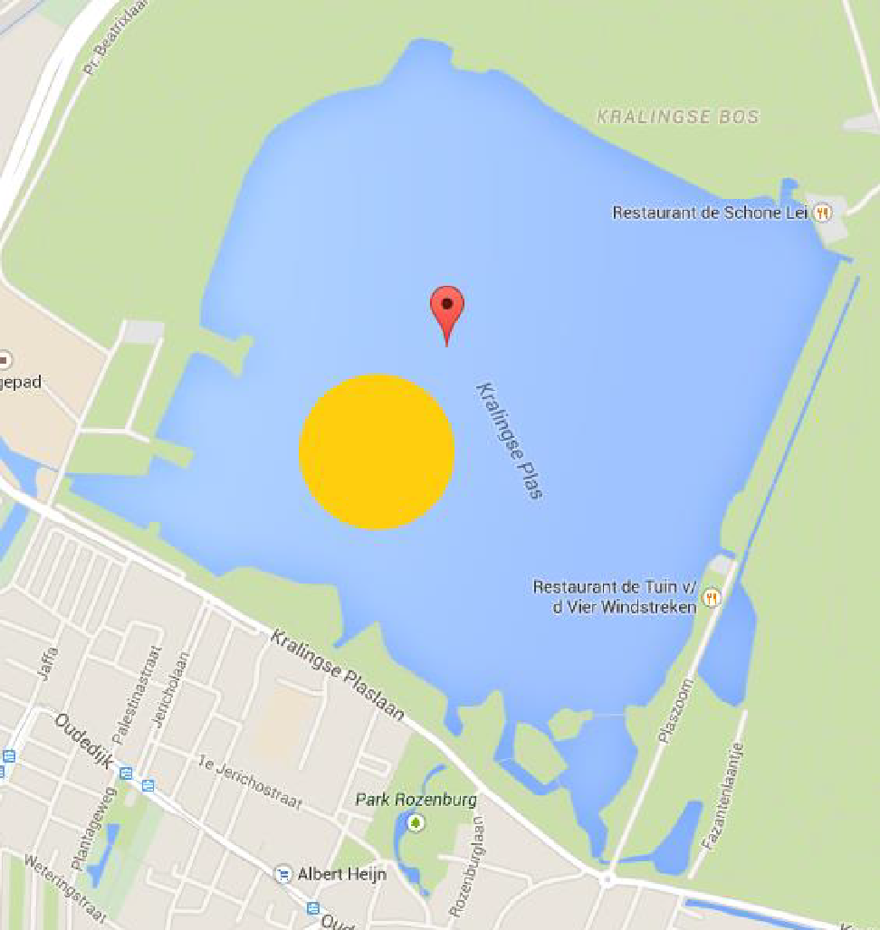COURSE AREA